
2
English overview: Year 3 – 2022-2023
 | Autumn 1 | Autumn 2 | Spring 1 | Spring 2 | Summer 1 | Summer 2
Reading | 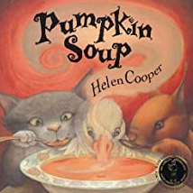  Badger books – independent guided reading book scheme | 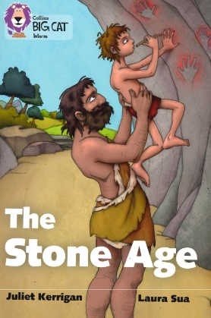  Badger books – independent guided reading book scheme  Coming Home poetry  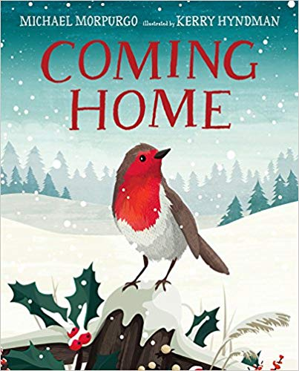 | 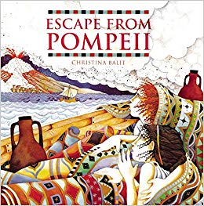  Badger books – independent guided reading book scheme | 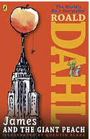  Badger books – independent guided reading book scheme | 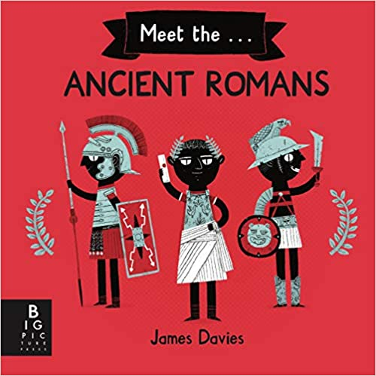  Badger books – independent guided reading book scheme | 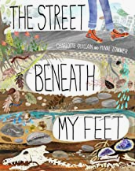  Badger books – independent guided reading book scheme
Writing | Flotsam: (3 weeks) Wordless picture book study  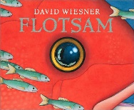  Form: Settings and character descriptions  Journals writing  Purpose: Writing to entertain  Traditional tales and tales from other cultures (3 weeks)    Form: Setting and character descriptions  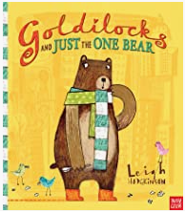  Form: Alternative endings  Purpose: Writing to entertain | Stone Age Boy: (3 weeks)  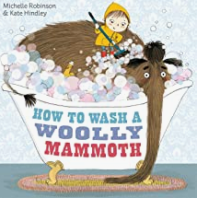  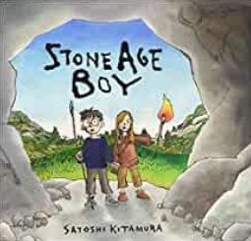  Form 1: Instructions  Form: Stone-Age Survival guides  Purpose: Writing to inform and explain  The dark – The King who banned the dark (3 weeks)  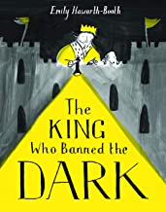  Form: short stories  Purpose: Writing to entertain | Krindlekrax: (3 weeks)  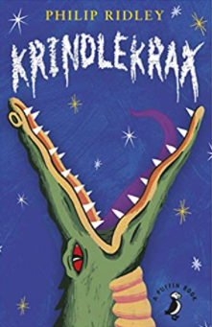  Form: Newspapers  Purpose: Writing to discuss/inform  Coming to England: (3 weeks)  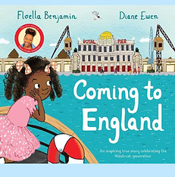  Form: Floella’s diary  Purpose: Writing to entertain  Form: Letters/Emails to MP  Purpose: Writing to inform | James and the Giant Peach (3 weeks)  Form: Setting description  Purpose: Writing to entertain  Form: Persuasive speech to Aunt Sponge and Aunt Spiker  Purpose: Writing to persuade  Poetry: (3 weeks)  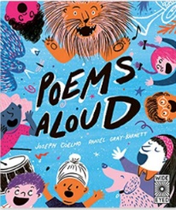  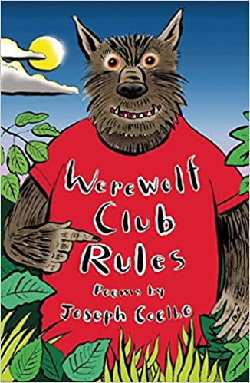  Form: Performance poetry  Purpose: Writing to entertain | Meet the Ancient Romans (3 weeks)  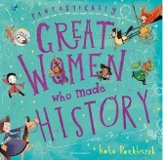  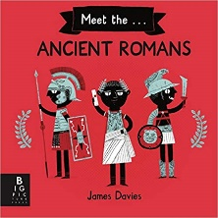  Form: Roman Emperor and Gladiator Trump cards  Form: Boudicca biographies  Purpose: Writing to inform and entertain  The Corinthian girl: (3 weeks)  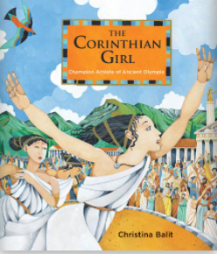  Form: diaries  Purpose: Writing to entertain  Form: Debate  Purpose: Writing to persuade | The street beneath my feet: (3 weeks)  Form: Scientific foldout fact-file  Purpose: Writing to inform  Why Water’s worth it (3 weeks)  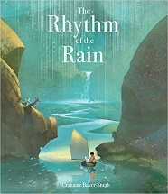      Form: Speech writing  Purpose: Writing to discuss  Form: Information campaign  Purpose: Writing to persuade  Form: Poetry  Purpose: Writing to entertain
curriculum writing and linked text drivers | Travel Brochure writing to persuade | Stone-Age Survival guides  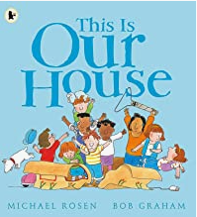  This is our house – No Outsiders PSHE  Bulling / discrimination | Volcanoes and natural disasters Pop-up book  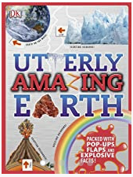  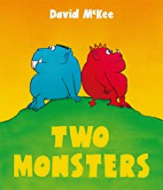  Two monsters – No Outsiders PSHE  Problem solving | Topical debate on Eastleigh  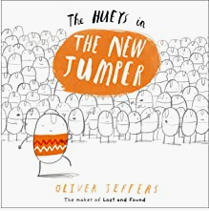The Huey’s in the new jumper – No Outsiders PSHE  Self-esteem |  | 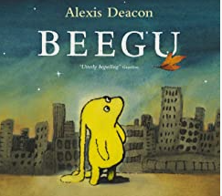  Beegu – No Outsiders PSHE  Bullying/Isolation

Writing progression for Year 3: Please use this to inform your objectives for teaching across the year
Composition and effect Ongoing objectives |  | Sentence structure | Structure and organisation | Spelling strategies | Vocab, Grammar and punctuation
• Compose and rehearse sentences orally (including dialogue), progressively building a varied and rich vocabulary  • Move vocabulary choices from generic to specific e.g. from ‘dog’ to ‘terrier’  • Expand detail/events through vocabulary (technical, vivid language) and explanation  • Evaluate and edit by assessing the effectiveness of their own and others’ writing and suggesting improvements | Make their writing clear in purpose  Plan their writing by discussing writing similar to that which they are planning to write in order to understand and learn from its structure, vocabulary and grammar  Plan their writing by discussing and recording ideas In narratives, create settings, characters and plot  Evaluate and edit by assessing the effectiveness of their own and others’ writing and suggesting improvements | • Draft and write an increasing range of sentence structures (simple and compound)  • Use some variation in sentence types (statement/ command/ question/ exclamation)  Ongoing:  Extend the range of sentences with more than one clause by using a wider range of conjunctions, including when, if, because, although (complex) | • Use simple organisational devices, e.g. headings and subheadings  • Organise writing into logical chunks and write a coherent series of linked sentences for each  • Select nouns and pronouns to provide clarity for the reader  • Vary nouns and pronouns to avoid repetition  • Use varied nouns and pronouns for cohesion  Onging:  Organise paragraphs around a theme | suffixes and understand how to add them (English Appendix 1: see doubling rules, changes to in-, re-, sub-, inter-, super-, auto-, anti-, -ation, changes to –ly, -sure, -ture/-cher, -ous plus necessary changes, -tion/-cian/-sion/-ssion)  • Form nouns using prefixes e.g. super, anti, auto  • Spell further homophones and understand their meaning  • Explore and accurately use word families based on common words, showing how words are related in form and meaning e.g. solve, solution, solver, dissolve, insoluble  Use the first two -three letters of a word to check its spelling in a dictionary Spell words that are often misspelt (English Appendix 1) • Use further prefixes and  Ongoing:  Write from memory simple sentences, dictated by the teacher, that include words and punctuation taught so far  Spell common exception words that have been taught | • Use conjunctions to express time, place and cause  • Use adverbs and prepositions to express time, place and cause  • Use inverted commas to punctuate direct speech  • Know when to use ‘a’ and ‘an’  • Use irregular simple past-tense verbs e.g. awake / awoke  • Use the present perfect form of verbs in contrast to the simple past tense e.g. he has gone out to play, he went out to play  • Use fronted adverbials • Use commas after fronted adverbials  Ongoing:  Proof-read for spelling and punctuation errors Indicate possession by using the possessive apostrophe with plural nouns  Propose changes to grammar and vocabulary to improve consistency, including the accurate use of pronouns in sentences

